V-Books Production Environment And Deployment Process

Prerequisites for V-Books:
- jdk1.5 or higher
- apache-tomcat-6.0
- apache-activemq-5.5
- apache-maven-3.0

1) We need to change the default heap size(JAVA_OPTS) for JVM in the following location “/etc/environment”.

JAVA_OPTS=-Xms256m -Xmx1024m -XX:PermSize=256m -XX:MaxPermSize=512m
2) We need to change the database engine from MYISAM to INNODB. Because MYISAM won't support transactions on multiple table, where as INNODB will support transactions. To change the engine, we need to add the following key, value pairs under [mysqld] section in the configuration file /etc/mysql/my.cnf .

- default-storage-engine=innodb

- transaction-isolation = READ-COMMITTED

3. innodb_buffer_pool_size= 512M
3) we need to enable the following tags and made change in it as below in
“/apache-activemq-5.5.1/conf/activemq.xml”.
<systemUsage>
<systemUsage>
<memoryUsage>
<memoryUsage limit="512 mb"/>
</memoryUsage>
<storeUsage>
<storeUsage limit="1 gb"/>
</storeUsage>
<tempUsage>
<tempUsage limit="1 gb"/>
</tempUsage>
</systemUsage>
</systemUsage>

4) We need to update the following lines in “/apache-activemq-5.5.1/bin/activemq.sh” as follows.

ACTIVEMQ_OPTS_MEMORY="-Xms256M -Xmx512M"

if [ -z "$ACTIVEMQ_OPTS" ] ; then
ACTIVEMQ_OPTS="$ACTIVEMQ_OPTS_MEMORY -Dorg.apache.activemq.UseDedicatedTaskRunner=false -Djava.util.logging.config.file=logging.properties"

fi

Database creation/deployment

- Open Linux Terminal
- Move to File System Path/Location where SQL scripts are available (create.sql, auth.sql)
- login to mysql
  - mysql -u<user name> -p<password>;
- At mysql execute the below sql command to create new database
  - Create database v-books;
  - Create user <user name> identified by <password>;
  - Grant all on <DB Name> .* to <user name>;
  - exit mysql command prompt
- At the terminal run the below command to exectue the sql scripts provided to create all the tables required in the in the database mentioned below.
- mysql -u <username> -p <password> <DBName> <create.sql;
- mysql -u <username> -p <password> <DBName> <auth.sql;

Steps to Deploy V_Books project into Tomcat server:
Step – 1:-
Check out the project from the below SVN repository url.
http://192.168.1.43/svn/vbooks/branches/v-books-1.0
Ex:-svn co http://192.168.1.43/svn/vbooks/branches/v-books-1.0/ -r <revision>

Step – 2:-
Now change the following values of keys in jdbc.properties file available in the below directory,
“../v-books/src/main/resources”.

Database changes:

- jdbc.username=<username>
- jdbc.password=<password>
- jdbc.url=jdbc:mysql://<host>:3306/<database name>?zeroDateTimeBehavior=convertToNull&amp;autoReconnect=true

and in MessagesBundle_en_US.properties also we need to change the following properties for Active MQ.

- ACTIVEMQ_BROKER_URL = tcp://<host>:61616
- ACTIVEMQ_IP = <host>

Step – 3:-
Now copy all the jar files(148) into application lib folder.
i.e.,
“../v-books/src/main/webapp/WEB-INF/lib”

List of jar files:

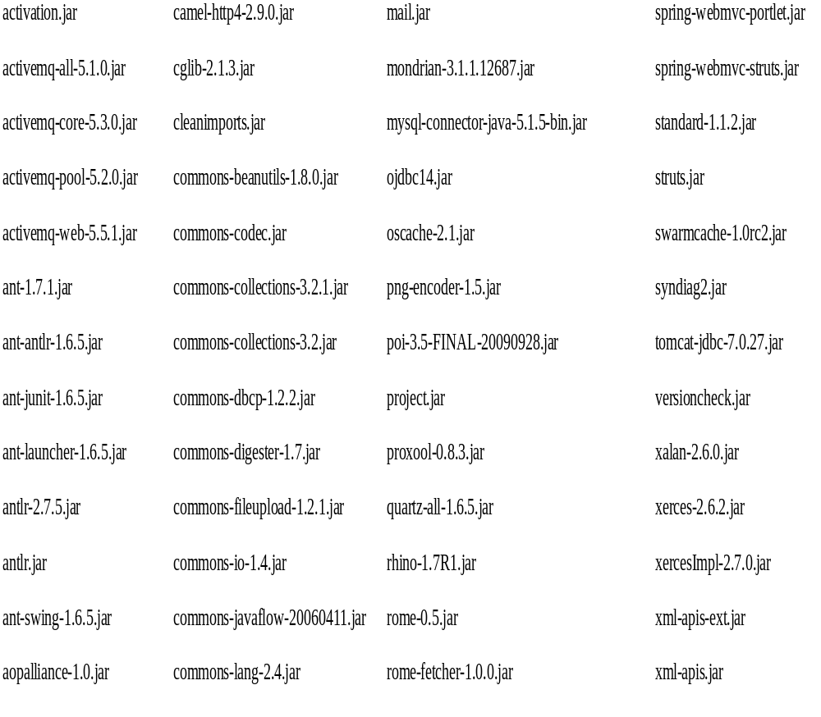
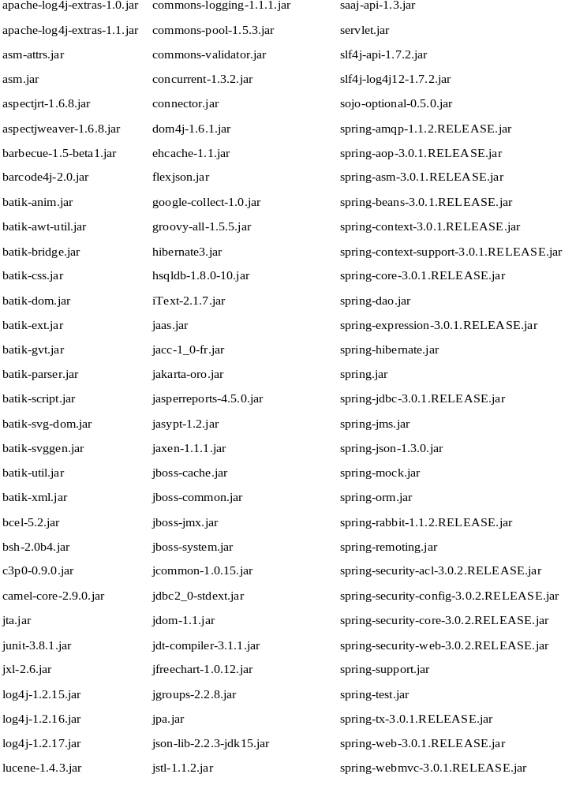

Step – 2:-
Now from project base directory, execute the following ant script to build the war file.
../../v-books> ant war
Step – 5:-
Now deploy the war file in Tomcat webapps folder, and then start tomcat and Active mq by using the following commands.

To start tomcat:-
../apache-tomcat-6.0.37/bin$ ./startup.sh

Using CATALINA_BASE: /home/sudhakar/Application/apache-tomcat-6.0.37
Using CATALINA_HOME: /home/sudhakar/Application/apache-tomcat-6.0.37
Using CATALINA_TMPDIR: /home/sudhakar/Application/apache-tomcat- 6.0.37/temp
Using JRE_HOME: /home/sudhakar/Application/jdk1.7.0_13
Using CLASSPATH: /home/sudhakar/Application/apache-tomcat- 6.0.37/bin/bootstrap.jar
../apache-tomcat-6.0.37/bin$

To stop Tocat:-
../apache-tomcat-6.0.37/bin$ ./shutdown.sh

To start Active MQ:-
/home/sudhakar/Application/apache-activemq-5.5.1/bin$ ./activemq start

INFO: Using default configuration
(you can configure options in one of these file: /etc/default/activemq /home/sudhakar//.activemqrc)
INFO: Invoke the following command to create a configuration file
./activemq setup [ /etc/default/activemq | /home/sudhakar//.activemqrc ]
INFO: Using java '/home/sudhakar/Application/jdk1.7.0_13/bin/java'
INFO: Starting - inspect logfiles specified in logging.properties and log4j.properties to get details
INFO: pidfile created : '/home/sudhakar/Application/apache-activemq- 5.5.1/data/activemq.pid' (pid '6976')
../apache-activemq-5.5.1/bin$

To stop Active MQ:-
../apache-activemq-5.5.1/bin$ ./activemq stop

---END---

